Date: 18/07/25
Roll No. and Name: 24BCE174 and Khush Pithva
Course Code and Name: 2CS502CC25 and Object Oriented Programming
Practical No: 2(a)
Aim: Write a program to determine if a given number is positive,negative, or zero using if-else statements

Methodology followed:
#include<bits/stdc++.h>
using namespace std;

int main()
{
int n;
cout<<"Enter number : ";
cin>>n;
if(n>0)cout<<"Positive Number "<<endl;
else if(n<0)cout<<"Negative Number"<<endl;
else cout<<"Number is Zero"<<endl;
return 0;

}
Output:
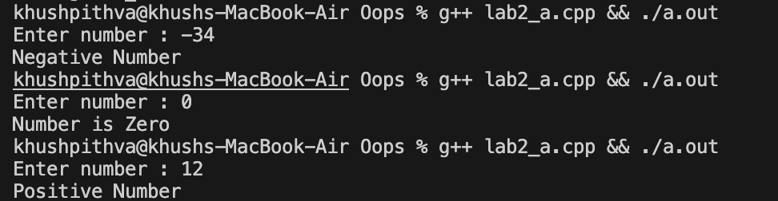

Practical No: 2(b)
Aim: Develop a program that takes a number and displays whether it is even or odd using the modulus operator and switch-case.

Methodology followed:
#include<bits/stdc++.h>
using namespace std;

int main()
{
int n;
cout<<"Enter a number: ";
cin>>n;

switch (n%2)
{
case 0:
cout<<"The number is even."<<endl;
break;
case 1:
cout<<"The number is odd."<<endl;
break;
case -1:
cout<<"The number is odd."<<endl;
break;
}
return 0;
}

Output:
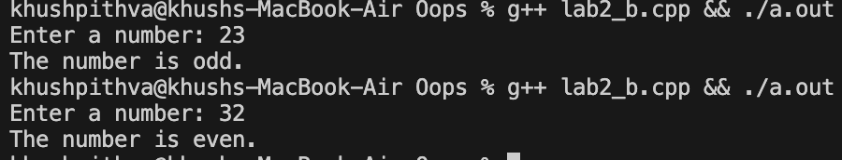

Practical No: 2(c)
Aim: Create a program that prints the factorial of a number using a for loop.

Methodology followed:
#include<bits/stdc++.h>
using namespace std;

int main()
{
int n;
cout<<"Enter a number: ";
cin>>n;

long long fact=1;
for (int i = 1; i <=n; ++i)
{
fact*=i;
}
cout<<"Factorial : "<<fact;

return 0;
}
Output:
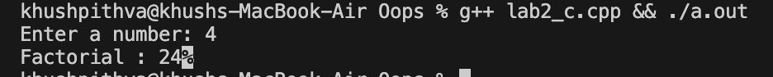
Practical No: 2(d)
Aim: Write a program that prints numbers from 1 to 50, skipping multiples of 3 using a while loop and continue statement.

Methodology followed:
#include<bits/stdc++.h>
using namespace std;
int main()
{
int i=1;
while(i<=50)
{
if(i%3!=0)cout<<i<<" ";
i++;
}
return 0;
}
Output:

Practical No: 2(e)
Aim: Implement a menu-driven program using switch-case for a basic calculator with operations like +, -, *, /.

Methodology followed:
#include<bits/stdc++.h>
using namespace std;

int main()
{
char c;
float a, b;

cout<<"Enter operation (+, -, *, /): ";
cin>>c;
cout << "Enter two numbers: ";
cin>>a>>b;

switch (c)
{
case '+':
cout<<"Result : "<<a+b<<endl;
break;
case '-':
cout<<"Result : "<<a-b<<endl;
break;
case '*':
cout<<"Result : "<<a*b<<endl;
break;
case '/':
if (b != 0) cout<<"Result:"<<a/b<<endl;
else cout<<"Division by zero is not allowed."<<endl;
break;
default:
cout<<"Invalid operator."<<endl;
}
return 0;
}

Output:

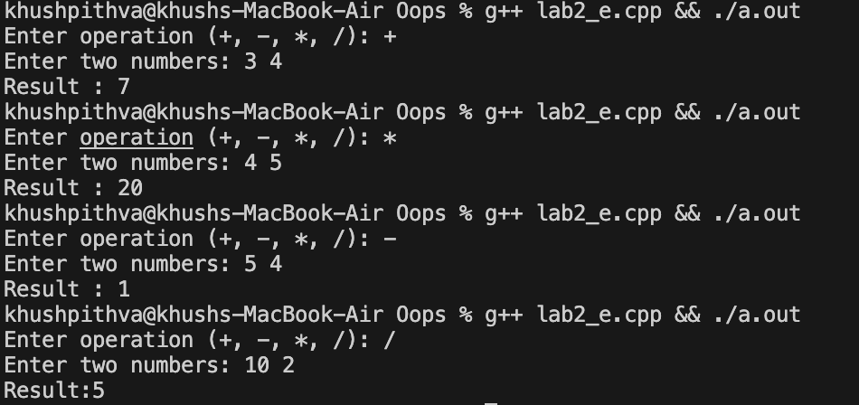

Conclusion:
This practical helped us understand basic control structures in C++ like if-else, switch-case, for and while loops. We applied them to solve real-world problems such as calculators, factorials, and condition-based outputs. These concepts are essential for logical decision-making in programming.

